Technical Proposal
Development of Two New Websites and Update of One Existing Website
For PHALS Peer Humanitarian Partners (PHPs)

Prepared By: Riseup Labs

1. Executive Summary
PHALS requires the development of two new organizational websites and the update of one existing website for its Peer Humanitarian Partners (PHPs): Ornab Cox's Bazar, Sujala Mahila Samity (SMS), and ASTA Foundation. The websites are intended to present each organization's work, programs, projects, initiatives, resources, and visibility materials through a user-friendly, responsive, and manageable digital platform.
The proposed solution focuses on practical CMS-based website delivery, responsive design, content management, basic interaction features, SEO readiness, security baseline, staff training, documentation, and post-launch support as requested in the SoW. The approach is intentionally lean to avoid unnecessary development cost while still meeting all stated requirements.

2. Project Understanding

2.1 Background
PHALS is implementing the ToGETHER 2.0! initiative with support from Malteser International. As part of capacity strengthening for local humanitarian partners, PHALS intends to support PHPs with improved organizational websites that can strengthen visibility, communication, and stakeholder engagement.

2.2 Project Objective
- Develop two new websites for two PHP organizations based on their organizational needs and branding.
- Update one existing PHP website to improve content structure, usability, responsiveness, and operational readiness.
- Enable PHP staff to manage content updates through a user-friendly CMS after handover.
- Provide basic interactive features such as feedback/contact forms, multimedia content areas, and a lightweight discussion/forum option only if confirmed during needs assessment.
- Ensure the websites are mobile responsive, search-engine friendly, and supported by basic security controls.
- Provide training and post-launch support until 30 April 2027 as per the SoW.

2.3 Scope Summary
Workstream | Coverage | Proposal Position
New Website Development | Two new CMS-based organizational websites | Develop from approved prototype, content structure, branding direction, and stakeholder feedback.
Existing Website Update | One existing organizational website | Improve within current website/CMS environment where possible; avoid unnecessary rebuild unless technically required.
Training and Handover | Staff training and documentation | Provide practical CMS training and handover documentation.
Post-Launch Support | Need-based support until 30 April 2027 | Support content uploading, section reworking, team queries, and troubleshooting with defined response times.

3. Proposed Technical Approach

3.1 Needs Assessment and Requirement Confirmation
The project will begin with a structured needs assessment to confirm each PHP's objective, audience, content readiness, branding materials, preferred language/content structure, existing website constraints, and staff capacity for content management. The output will be a concise needs assessment report and a recommended website architecture.

3.2 Information Architecture and Prototype
Based on the needs assessment, an indicative sitemap and prototype will be prepared for review. The prototype will focus on navigation, homepage structure, content blocks, program/project presentation, resources, multimedia areas, and contact/feedback interaction. At least two rounds of revisions will be managed based on stakeholder feedback.

3.3 CMS-Based Development
A CMS-first approach is recommended so PHP staff can manage website content after handover without continuous developer dependency. WordPress is recommended for the new websites because it is widely used, cost-effective, and suitable for NGO/corporate information websites. Drupal may be considered only if PHALS/PHPs specifically prefer it or if the existing website already uses Drupal.

3.4 Existing Website Update Strategy
The existing website will first be reviewed for CMS, hosting, theme, plugin/module condition, content structure, mobile responsiveness, security posture, and update constraints. The update will prioritize practical improvements within the current setup to control cost and reduce risk. If a major rebuild is required, it should be treated as a separate decision after technical audit.

3.5 Responsive and Accessibility-Aware UI Implementation
The websites will be developed using responsive layouts so users can access information from desktop, tablet, and mobile devices. Accessibility-aware practices will be applied at a practical level, including readable typography, clear navigation, alt text support for images, proper heading structure, and form labels.

3.6 Security, Privacy, and Data Protection Baseline
The proposal includes baseline website security measures suitable for public informational websites: SSL/HTTPS, strong admin access controls, CMS role management, secure form handling, anti-spam controls, routine updates, backup configuration, and privacy-conscious handling of user-submitted contact/feedback data.

4. Scope of Work

4.1 Scope for Two New Websites
- Needs assessment and website planning for each new website.
- Sitemap and information architecture based on approved content structure.
- Prototype preparation and two revision rounds based on stakeholder input.
- Responsive CMS theme setup and customization aligned with each PHP's branding and visibility needs.
- Core content sections for organization profile, programs/projects, resources, news/multimedia, and contact/feedback.
- CMS admin configuration with user roles for content management.
- Technical SEO baseline, mobile responsiveness, and basic performance optimization.
- Form setup for contact or feedback submission.
- Security baseline, backup configuration, and handover documentation.

4.2 Scope for Existing Website Update
- Review existing website structure, CMS/admin access, hosting, theme/plugin/module condition, and visible issues.
- Update content sections and visual structure as agreed after review.
- Improve mobile responsiveness and navigation where required.
- Apply basic SEO, security, backup, and CMS hygiene improvements where technically feasible.
- Support content uploading and section reworking within the agreed update boundary.
- Provide documentation for the updated website management process.

4.3 Common Website Components
Component | Included Scope | Boundary Note
Public Pages | Homepage, organization profile, programs/projects, resources/media/news, contact/feedback pages as finalized in sitemap. | Final page list depends on content readiness and needs assessment.
CMS Admin | Admin login, content editing, media upload, menu management, and basic user roles. | No complex workflow engine unless separately approved.
Forms | Contact/feedback forms with validation and anti-spam protection. | No CRM or advanced automation unless separately approved.
Forum / Discussion | Basic moderated discussion/forum feature only if confirmed during needs assessment. | Complex community platform, member portal, or custom moderation system is out of scope.
Multimedia | Image galleries, document uploads, and embedded videos where content is provided. | Video production/editing is not included.
SEO | Metadata, clean URLs, sitemap, robot settings, image alt text support, and indexing readiness. | Paid SEO campaigns and content marketing are not included.

5. Development Methodology
A controlled iterative methodology is recommended because the project involves three organizations, stakeholder review, prototype feedback, and content coordination. The methodology balances structure with flexibility while keeping development scope under control.
- Initiation and access collection: confirm PHP focal persons, website ownership, hosting/domain access, existing website credentials, and available content.
- Needs assessment: collect organizational needs, audience expectations, content requirements, branding inputs, and website management capacity.
- Architecture and prototype: prepare sitemap, content structure, and prototype for stakeholder review.
- Revision cycle: manage two structured revision rounds before development finalization.
- Development: implement approved pages, CMS structure, forms, multimedia areas, SEO baseline, and security controls.
- QA testing: conduct functional, responsive, browser, admin workflow, content, SEO, performance sanity, and security baseline tests.
- Deployment and handover: deploy approved websites, provide documentation, credentials, training, and support process.
- Post-launch support: provide need-based support until 30 April 2027.

6. Proposed Technical Stack
The following stack is proposed to keep the solution practical, maintainable, and cost-effective for NGO/PHP websites.
Layer | Recommended Technology | Purpose / Rationale
CMS | WordPress CMS for new websites | Suitable for organizational websites, staff-managed content, quick delivery, and lower maintenance cost.
Existing Website Update | Current CMS/technology of existing website where feasible | Avoids unnecessary rebuild cost and reduces migration risk.
Backend Runtime | PHP 8.3+ where hosting allows | Aligned with current WordPress hosting recommendations.
Database | MySQL 8.0+ or MariaDB 10.6+ | Stable CMS database layer for content, settings, and admin data.
Frontend | HTML5, CSS3, JavaScript, responsive theme framework | Responsive layouts, clean navigation, and accessible content presentation.
Forms | CMS form plugin/module with validation and spam protection | Handles contact/feedback forms without custom backend development.
SEO | CMS SEO configuration, XML sitemap, metadata, readable URLs | Supports search engine crawling and indexing readiness.
Security | HTTPS/SSL, admin role control, backups, plugin update discipline, form protection | Baseline protection for public websites and submitted form data.
Analytics | Basic website analytics integration if account access is provided | Allows PHPs to monitor traffic and content performance without custom dashboards.
Hosting | Linux hosting with Apache/Nginx, SSL, backup, and CMS-compatible resources | Standard production hosting model for CMS websites.

7. Technical Diagrams and Architecture

7.1 High-Level System Architecture Diagram

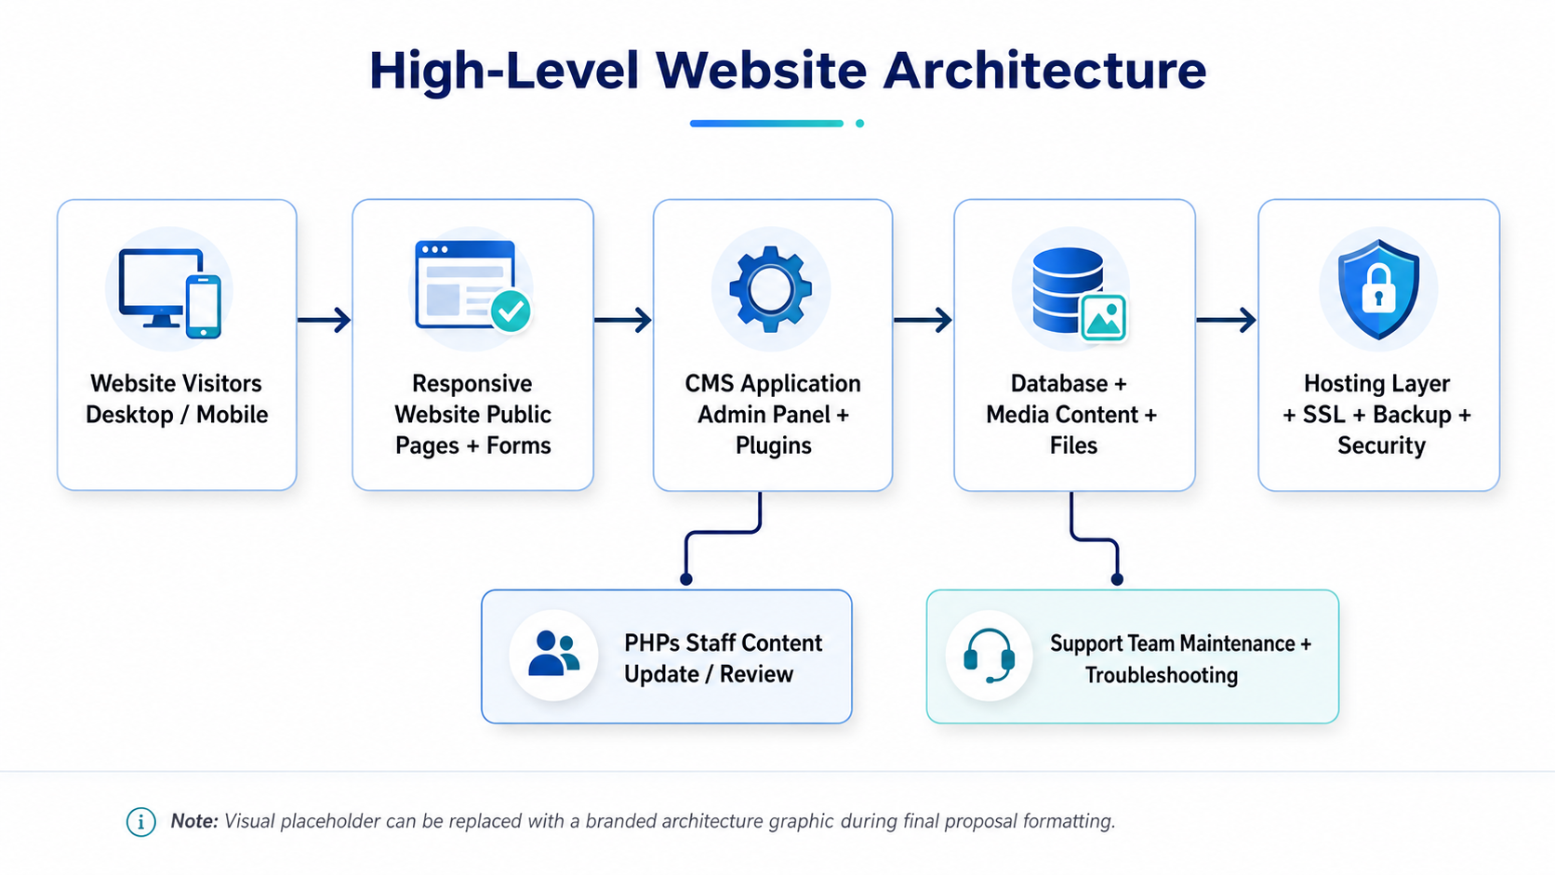

7.2 Content Publishing and Website Management Flow
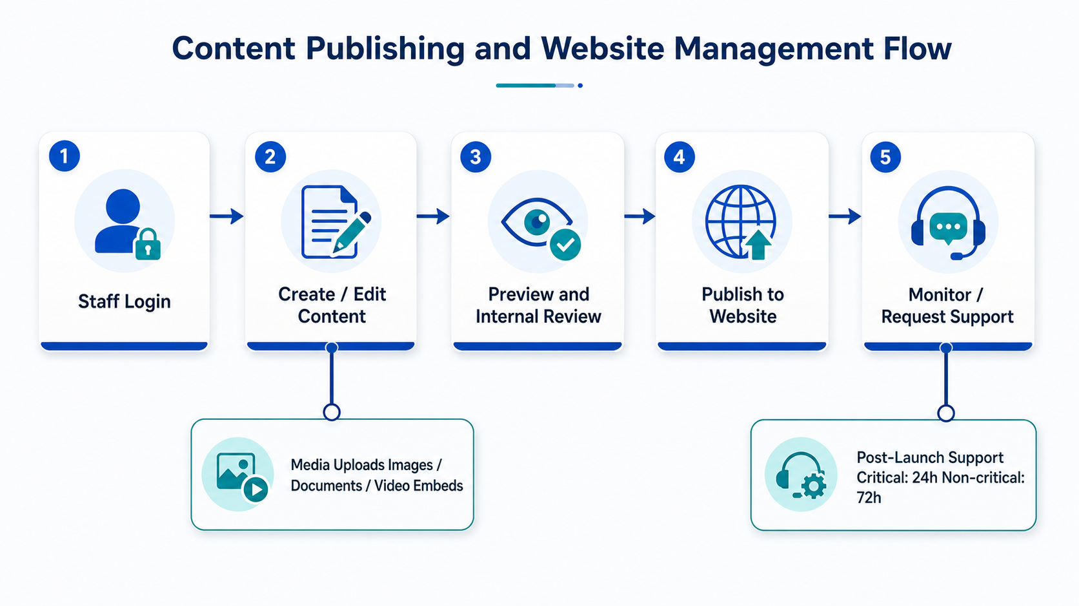

7.3 Indicative Information Architecture
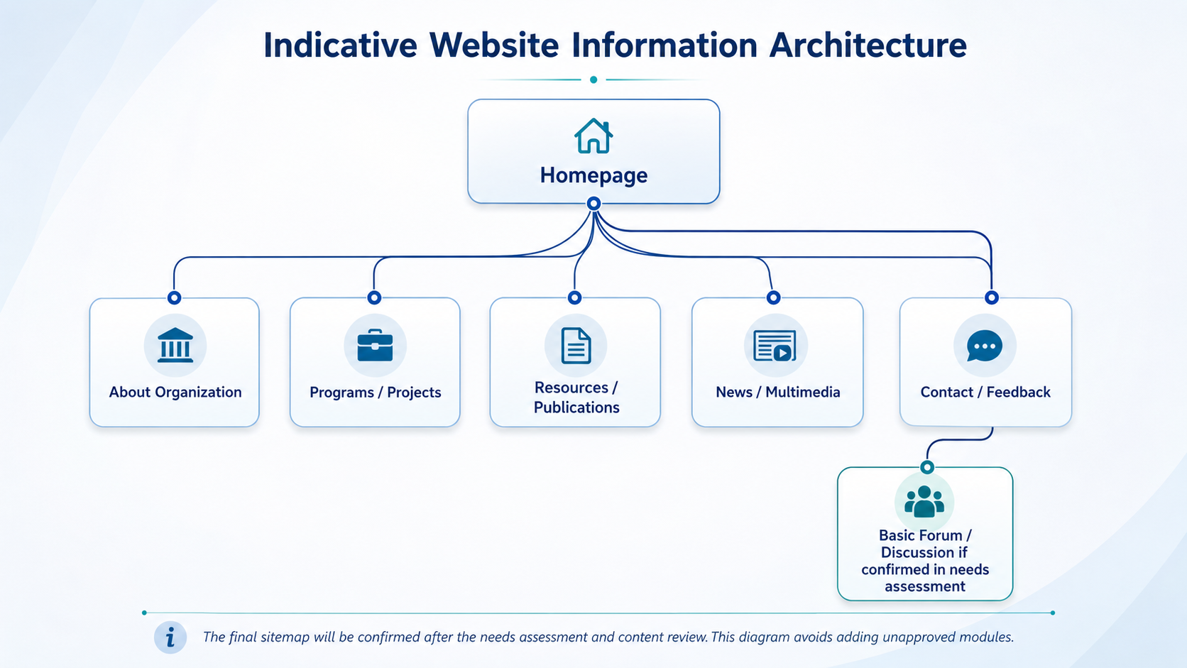

8. Quality Assurance Testing Approach
The QA scope focuses on validating that the websites are functional, responsive, manageable, and ready for public use. Testing will be performed before deployment and after deployment verification.
QA Area | Test Coverage
Functional Testing | Navigation, page links, forms, media display, search if included, CMS content update paths, and basic forum/discussion if confirmed.
Responsive Testing | Desktop, laptop, tablet, and mobile screen checks for layout, menu, images, forms, and readability.
Cross-Browser Testing | Latest stable versions of Chrome, Edge, Firefox, and Safari where accessible.
CMS/Admin Testing | Login, role access, page/post editing, media upload, menu update, and content publishing verification.
Content QA | Final content placement, image/document links, alt text support, basic formatting, and broken link check.
SEO Readiness Check | Page titles, meta descriptions, clean URLs, XML sitemap, robots settings, and indexability sanity checks.
Performance Sanity Check | Image optimization, caching setup if available, and page-load sanity checks for key pages.
Security Baseline Check | HTTPS, admin access protection, form validation, spam protection, plugin/module hygiene, and backup verification.
Deployment Verification | Live URL access, SSL status, form submission test, CMS login test, and post-deployment smoke testing.

9. Deliverables
Deliverable | Description
Needs Assessment Report | User requirements, organizational needs, audience expectations, website recommendations, and content/branding notes.
Website Architecture and Sitemap | Approved sitemap and page/content structure for the two new websites and update scope for the existing website.
Initial Prototype | Prototype for review with at least two revision rounds based on stakeholder input.
Two New Websites | Fully developed CMS-based organizational websites with approved pages, content areas, forms, multimedia support, SEO baseline, and security setup.
Updated Existing Website | Existing website improved according to agreed update scope, including content/section improvements, responsiveness, SEO/security baseline where feasible.
QA Test Report | Summary of testing coverage, issues identified, fixes applied, and deployment readiness status.
Website Management Documentation | Admin guide covering content update, media upload, menu/page editing, and basic maintenance instructions.
Training Session | Practical CMS/content management training for PHPs staff.
Post-Launch Support | Need-based support until 30 April 2027, including content uploading, section reworking, team support, and troubleshooting.

10. Assumptions and Dependencies
- PHALS/PHPs will provide focal persons for requirement confirmation, prototype feedback, content approval, and final handover.
- Organization logos, branding materials, profile text, program/project content, images, reports, and multimedia assets will be provided by the respective PHPs.
- Domain, hosting, SSL, and existing website admin/hosting access will be provided or confirmed before development and deployment.
- The existing website update will be performed within its current technical environment unless audit findings require a separate rebuild decision.
- Content writing, translation, photography, video production, paid SEO campaigns, and third-party subscription fees are not included unless separately agreed.
- Final website language and content structure will be confirmed during the needs assessment stage.
- Timeline depends on timely feedback during the two prototype revision rounds and timely provision of website content.

11. Post-Launch Support Plan
Post-launch support will continue on a need basis until 30 April 2027, aligned with the SoW. The support model is intended to keep the websites stable and assist PHP teams after handover.
Support Area | Coverage
Content Uploading | Assist with uploading approved content, images, documents, and multimedia materials when required.
Section Reworking | Assist with reworking existing website sections to improve layout, clarity, or usability within the agreed scope.
Team Support | Answer CMS/content management questions and guide PHP staff through basic website operations.
Troubleshooting | Resolve technical issues that affect website accessibility, forms, content display, CMS access, or basic functionality.
Response Time | Critical issues: within 24 hours. Non-critical issues: within 72 hours.

12. Out of Scope
The following items are excluded to keep the proposal aligned with the SoW and avoid unnecessary development cost:
- Financial proposal, pricing, or payment schedule.
- E-commerce, payment gateway, donation system, or online fundraising module.
- Beneficiary database, case management system, CRM, ERP, or project management platform.
- Custom mobile application.
- Complex member portal, role-based community platform, or advanced forum with custom moderation workflows.
- Advanced analytics dashboard beyond basic website analytics integration.
- Content writing, translation, photography, video editing, or graphic design production unless separately agreed.
- Paid SEO campaign, social media campaign, advertising, or digital marketing execution.
- Third-party subscription fees, hosting renewal fees, domain renewal fees, or premium plugin/theme license costs unless separately approved.
- Major rebuild of the existing website if the audit finds that the current technical base cannot support the requested update. Such rebuilding should be treated as a separate decision.

13. Conclusion
This technical proposal presents a focused and practical approach for developing two new PHP partner websites and updating one existing website in alignment with SoW. The proposed solution emphasizes clean design, responsive development, simple content management, SEO readiness, security, staff training, QA testing, and post-launch support. By keeping the scope limited to the stated requirements, the project can deliver functional, professional, and easy-to-maintain websites that strengthen the digital visibility and communication capacity of the PHP organizations.

